www.Belbin.com.au

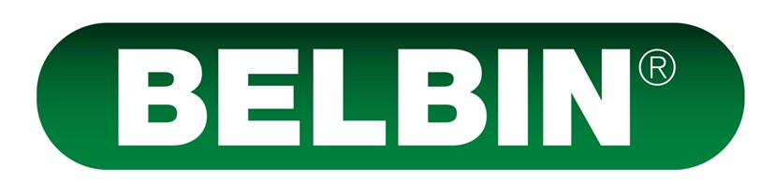

2020 Pricing Guide
All prices inclusive of GST

3 Options to Access Belbin Profiles and Reports

1 – Online Paypal / Credit Card purchase
(Price Range Aud $63 - $83 per profile)
Buy online from our store using PayPal / Credit Card (Belbin Australia is a subsidiary of Sabre Corporate Development / Adventure Conventions Pty Ltd). We then set up your own online “Working Account” which you can access online, has some basic admin features and that you can check progress with. Profiles come automatically to you as PDF files upon completion, and any required team reports upon request.

2 – Contact us first and we can invoice you
(Price Range Aud $63 - $83 per profile)
Call or email us to discuss your needs, we can then invoice you (Belbin Australia is a subsidiary of Sabre Corporate Development / Adventure Conventions Pty Ltd) and when processed, tailor and set up your very own online “Working Account” which you can use to access and check progress. Profiles will come to you automatically upon completion as PDF files upon completion, and any required team reports upon request.

3 – Purchase your own Belbin Interplace System
(Price Range Aud $23 - $45 per profile)
You will then have your own in-house capability to do everything that we can do. Set up your own working accounts, process profiles and infinite combinations of reports with complete access and control. Comes with a host of great functions and extras, with far cheaper per profile pricing and free team, relationship and job comparison reports (initial job requirements exercise equals one profile unit). Call or email to see if this is viable for you based on your anticipated usage.

Belbin Individual Profiles and Reports

A/ Via an online ‘Working Account’ under our online system
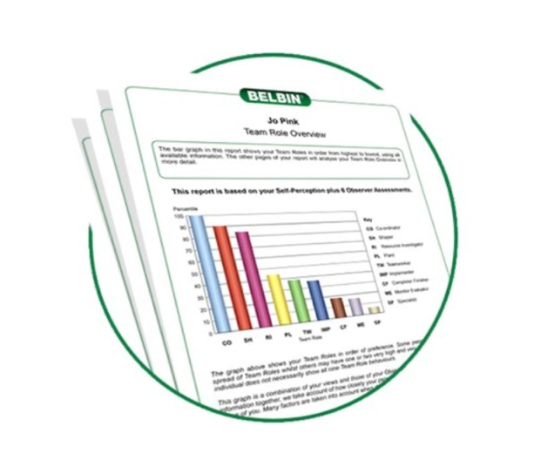
We set up a sub account under our system for you. Including the full Belbin self-perception questionnaire conducted online; and 360 ̊ observer input (as required with standard online purchase system is set 4 Observers). Completed reports are sent to you and / or participants automatically as a PDF file (11-14 report pages depending upon whether SPI with OBS or SPI only).
Retail Rate for Online Sales / Working Accounts
Up to 50 profiles: Aud $83 per profile
50 – 99 profiles: Aud $73 per profile
100 – 199 profiles Aud $63 per profile
Special Belbin Accredited User Rate
$63 per profile flat rate

B/ Via your own full online Belbin Interplace System
Purchase of a full Belbin Interplace system gives you complete access and control to set up and administer all of your own Belbin profiling and reports along with many features and extras (adding your own logo to reports, video cameos, special features etc). Call or email to see if your planned use of Belbin makes this a viable option for you.
Initial system purchase and set up is for 200 units @$45 per profile. This gives you the full system, all features and extras and 200 profiling units.
Aud $9 000 (including full system functionality and 200 profiling units).

Belbin Interplace Online System Owner Bulk Unit Replacement Prices
(for once your initial 200 units are used):
Up to 50 profiles: Aud $41 per profile
51 – 99 profiles: Aud $35 per profile
100 – 199 profiles: Aud $31 per profile
200 – 499 profiles: Aud $29 per profile
500 – 999 profiles: Aud $25 per profile
1000 plus profiles: Aud $23 per profile
Team Reports: Free of charge / infinite use with own system.
Working Relationship Reports: Free of charge / infinite use with own system.
Job Requirements Exercise: Subtracts one profile unit per use.
Job Comparison Reports: Free of charge / infinite with own system.

Team Reports
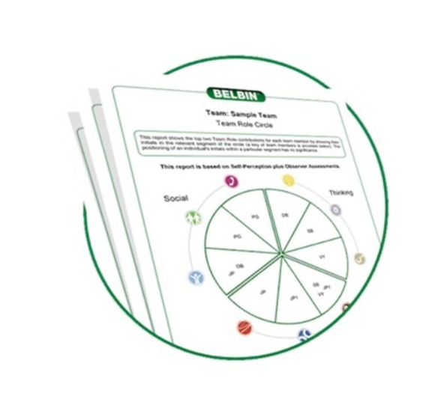
Combines the data from individual profiles to offer a comprehensive team snapshot and practical advice based upon the team role chemistry of any selected team. People need to have competed an individual profile first. Simply select and notify us of the required people for inclusion. If purchased online you need to check progress of your online account and let us know when your team have completed their individual profiles to your satisfaction.
Retail Rate: Aud $150 per team report
Accredited User Rate: $110 per report
Free if you own your own system

Working Relationship Reports
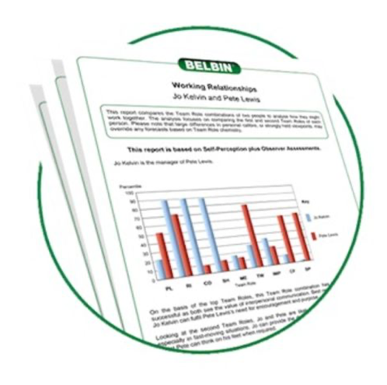
These short one page reports offer a team role snapshot and useful advice for the relationship between any two people for whom you already have individual profiles.
Retail Rate: $30 per report
Accredited User Rate: $20 per report
Free if you own your own system

Job Requirements Exercise / Comparison Reports

A/ The Job Requirements Exercise / Report
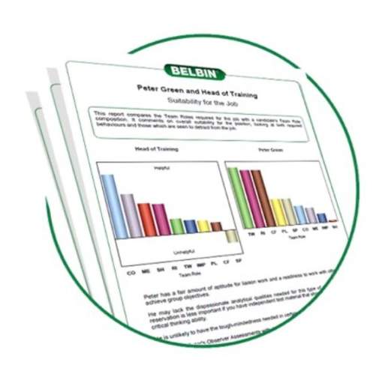
Completed by the manager or person hiring for the role / position / job or managing the placement, as well as offering Observer inputs from others that know the role well. It gives a snapshot and practical advice based on the behavioural requirements of the role.
Retail Rate: $85 per report
Accredited User Rate: $65 per report
Uses one SPI profiling unit per report if using your own system

B/ The Job Comparison Report
Compares in Team Role terms with useful advice any candidates for whom you have individual profiles and the ‘Job Requirements / Report’ for Team Role suitability.
Retail Rate: $40 per report
Accredited User Rate: $30 per report
Free if you own your own system

Film / DVD Trainers Package – ‘Fire Toast and Teamwork”
DVD Package or Online Streaming Packages available. Take the pressure off the start of your sessions, simply hit play and let this professional, engaging and amusing Film / DVD explain the Team Role theory and the basics of the 9 Team Roles. Heaps of extras and comprehensive instructions, workbook and handouts come with the DVD version of the package, downloads of PDF can be accessed with the streaming options.
Retail Rate: $1 200
Accredited User Rate: $1 000

Belbin Team Building Games ‘Co-Operate’ Package
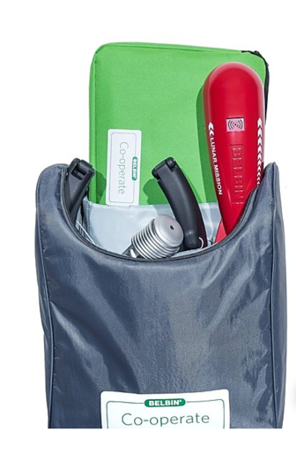
Three great team building games in a backpack complete with all instructions and props. Easy to set up and use to bring the team roles to life and add some action-learning to your Belbin sessions.
Retail Rate: $1 200
Accredited User Rate: $1 000

Belbin Book – Guide to Succeeding at Work
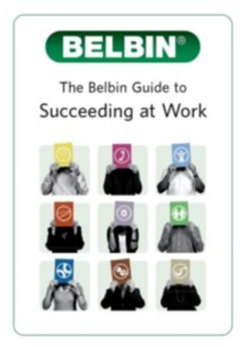
An easy to use and practical guidebook to making use of the Belbin team Roles and your own profiles at work. Useful for any person who uses the model, and great follow-through for session participants to help take their knowledge to the next levels back at work.
Retail Rate: $17 per copy
Accredited User Rate: $15 per copy

Official Accreditation in Belbin (In Person or Online)
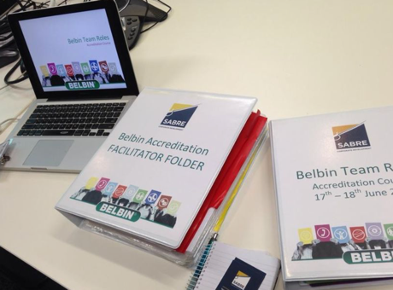
Whilst Accreditation is not mandatory to use Belbin, it is of course highly recommended if seeking to use the model optimally, at depth and with enhanced credibility. The two-day official Belbin Accreditation Course includes in-depth instruction in all aspects of the model and its uses, globally recognised certification, access to special resources and the right to use the Belbin “Accredited User” logo.
Aud $1 800 for purely online course
Aud $2 200 per person face-to-face course

A Belbin “How To” Session
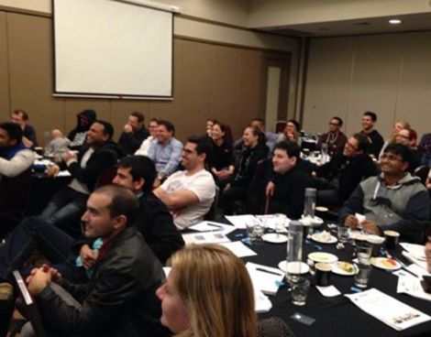
These are half to one-day sessions that are tailored to bring new and existing Belbin users “up to speed” on how to understand the Model, interpret the profiles and reports and make practical use of the Model ongoing. This is a great option if you have people needing to get familiar with (or re- acquainted with) Belbin but not needing to be fully Accredited.
POA (based on numbers and whether online or face-to-face)

GetSet Profiles for Students
The very latest version of the Belbin profiles and reports for high school and university students (recommended age bracket 14 – 21years). Designed, normed and scripted to help students identify and articulate their strengths. Comes complete with a comprehensive set of reports and inbuilt student workbook.
Up to 500 profiles: Aud $24 per profile
501 - 1000 profiles: $22 per profile
1000 plus profiles: $20 per profile

